**Case Study: Exhibits shown to Asseement team during assessment**

(Goodwill Equipment Co Ltd)

Contents

Ex – 1 : Business Peformance Report 1

Ex – 2 : New products development and business returns 2

Ex – 3 : Product improvements: 2

Quality planning 3

EX – 3 QUALITY PLAN FOR MOTORS 3

EX – 4 QUALITY PLAN FOR PUMPS 4

Quality performance Report 5

Ex – 5 : Product performance – In process quality level 5

Ex – 6 : Product performance (ppm level) customer end) 5

Ex – 7 : Process Capability studies 6

Ex – 8 Control Charts 8

Ex – 9 Fault Analysis Reports 11

Ex – 10 : Cost Of Poor Quality 12

Ex – 11 : List of Kaizen Projects executed 13

Waste Reduction 14

Ex – 12 : 3 M Project executed 14

Customer quality 15

Ex – 13 : Customer ratings (Scale of 10) 15

Ex – 14 : Customer Complaints 15

Equipment Performance 16

Ex – 15 : OEE (%) 16

Ex – 16 : Breakdown (% of available hours) 16

Ex – 17 : Energy Consumption 16

Ex – 18 : Environmental Performance 17

Ex – 19 : Employee productivity 18

Ex – 20 : Internal Management Review : Summary Report 19

# Ex – 1 : Business Peformance Report

|  |  |  |  |  |  |  |  |
| --- | --- | --- | --- | --- | --- | --- | --- |
|  |  | 2013-14 | | 2014-15 | | 2015-16 | |
|  |  | **Target** | **Achieved** | **Target** | **Achieved** | **Target** | **Achieved** |
| Total Sales | Crores | 35.0 | 35.8 | 50.0 | 48.7 | 65.0 | 68.8 |
| Exports | Crores | 6.0 | 6.2 | 9.5 | 10.4 | 13.5 | 14.6 |
| Gross Profits | Crores | 5.5 | 5.7 | 6.0 | 6.4 | 7.5 | 8.1 |
| Profits after tax and Depreciation | Crores | 3.0 | 2.6 | 3.0 | 3.2 | 4.5 | 5.2 |
| Centrifugal Pumps & monoblocks | Nos | 750 | 790 | 800 | 815 | 850 | 922 |
| Crores |  | 13.3 |  | 15.5 |  | 19.5 |
| Vertical & Submersible pumps | Nos | 200 | 168 | 250 | 252 | 275 | 281 |
| Crores |  | 18.2 |  | 28.1 |  | 37.0 |
| Valves | Nos | 300 | 300 | 300 | 390 | 700 | 755 |
| Crores |  | 2.7 |  | 3.3 |  | 9.5 |
| Spares & AMC | Crores | 2.0 | 1.6 | 2.0 | 1.8 | 3.0 | 2.8 |
| Capex investment | Crores | 2.5 | 0.4 | 3.0 | 2.5 | 1.5 | 1.1 |
| Assets | Crores | 5.8 |  | 6.0 |  | 7.45 |  |
| Net outstandings | Crores | 8 | 11.8 | 15 | 19.4 | 20 | 25.6 |
| Inventory turnover ratio |  | 7 | 8.4 | 9 | 7.4 | 12 | 16.8 |
| Value added per employee | Lakhs | 6.8 | 9.5 | 10.0 | 12.5 | 11.0 | 16.3 |
| Delivery performance | % | 90 | 84 | 90 | 83 | 90 | 92 |

# Ex – 2 : New products development and business returns

|  |  |  |  |  |
| --- | --- | --- | --- | --- |
|  | 2012-13 | 2013-14 | 2014-15 | 2015-16 |
| No of new products  Developed | 6 | 2 | 3 | 4 |
|  | New series of Sluice Valves | Footvalves | XU Horizontal Slurry Pumps | Special application centrifugal pumps for Ethylene oxide handling;  Submersiblemotors in ratings of 25,32 hp |
| Revenue % from new  Products | 7.9 % | 8.1 % | 11.2 % | 13.4% |

# Ex – 3 : Product improvements:

|  |  |
| --- | --- |
| **2014** | Developed Monoblock pumps for corrosive, high temperature applications for pharma sector applications |
| **2015** | Redesign volute of S10 series heavy duty Centrifugal pumps to increase pump eficiency from existing 55- 65 % upto 78 % |
| **2016** | Introduction of rubber lined pumps |

# Quality planning

# EX – 3 QUALITY PLAN FOR MOTORS

|  |  |  |  |
| --- | --- | --- | --- |
|  | Test | Clause / Standard | Frequency |
|  | High Voltage Test | 25 IS 7538 | Each Motor |
| 1 | Insulation Resistance Test | 26 -do- | Each Motor |
| 2 | No load running of motor and reading of current and power input at rated voltage and supply frequency. | 24.1 -do- | Each Motor |
| 3 | Locked rotor test for locked rotor current, powr input at a suitable voltage and supply frequency. | 24.3 -do- | Each Motor |
| 4 | Reduced Voltage running up test at 60 per cent of rated voltage | 11.1 (e ) IS 9079:2002 | Each Motor |
| 5 | Measurement of stator Resistance | 6 IS 4029 | One out of every 5 Motors or less of identical type & design produced in a batch |
| 6 | Temperature rise test at Rated voltage | 11.2.3 IS 9079:2002 and  Table 5 | -do- |
| 7 | Temperature rise test at 85 percent of rated voltage | 11.2.3 and -do-Table 5 | -do- |
| 8 | Insulation resistance test after temperaturise test | 26 IS 7536 | -do- |

# EX – 4 QUALITY PLAN FOR PUMPS

|  |  |  |  |  |
| --- | --- | --- | --- | --- |
| **TEST** **DETAILS** | | **LEVELS** **OF** **CONTROL** | | |
| **Requirement** | **Test** **Methods**  **Clause** **Reference** | **Frequency** | **Remarks** |
| Material of construction of various parts (Mechanical test) | 6.1 IS 9019:2002 | 3 samples from each batch of various parts received | The parts should conform to the relevant specifications as given in GEC Part Sepcifications List |
| General requirement | IS 5120 | Each monoset produced |  |
| Hydrostatic test of pump casing | 12.2 IS 9079:2002 | Each pump casing |  |
| Impeller & rotor balancing | 12.3 -do- | Each impeller & rotor |  |
| Alignment check |  | Each Pump |  |
| Noise Test |  | Each Pump |  |
| Design features pump test and verification of guarantee | 5.1 S 11346 | Each pump : Duty point verification  One out of every 5 pumpset or less of identical type & design produced in a batch for full Duty cycle  Slurry and Vertical Turbine pumps : Each pump | In case of failure all the pumps shall be tested till three consecutive samples pass. |
| Painitng check | Visual | Each Pump |  |

# Quality performance Report

# Ex – 5 : Product performance – In process quality level

|  |  |  |  |  |  |  |
| --- | --- | --- | --- | --- | --- | --- |
|  | 2013-14 | | 2014-15 | | 2015-16 | |
|  | Target | Achieved | Target | Achieved | Target | Achieved |
| Centrifugal Pumps | 20000 | 24050 | 12000 | 13497 | 6000 | 9761 |
| Monoblock Pumps | 20000 | 28050 | 12000 | 18440 | 10000 | 12100 |
| Vertical / Submersible  Pumps | 10000 | 11904 | 6000 | 7936 | 4000 | 3559 |
| Valves | 20000 | 35400 | 20000 | 24000 | 10000 | 13450 |
| Cost of internal ppm  as % of sales |  | 1.01 |  | 0.94 |  | 0.65 |

# Ex – 6 : Product performance (ppm level) customer end)

|  |  |  |  |  |  |  |
| --- | --- | --- | --- | --- | --- | --- |
|  | 2013-14 | | 2014-15 | | 2015-16 | |
|  | Target | Achieved | Target | Achieved | Target | Achieved |
| Centrifugal Pumps | 20000 | 18400 | 10000 | 8030 | 5000 | 4320 |
| Monoblock Pumps | 20000 | 16400 | 10000 | 12100 | 5000 | 7560 |
| Vertical / Submersible  Pumps | 10000 | 8800 | 6000 | 5950 | 2000 | 2200 |
| Valves | 20000 | 28900 | 10000 | 18900 | 12000 | 12010 |
| Cost of external ppm  as % of sales |  | 2.1 |  | 1.5 |  | 0.9 |

Industry Average (Customer end ppm for pumps) : 1200

Best in class (Customer end ppm for pumps) : 150

# Ex – 7 : C:\Users\Anupam.Kaul\Dropbox\Zed Assessor Training Program\Reference material for case study\PC Temp Rise.pngProcess Capability studies

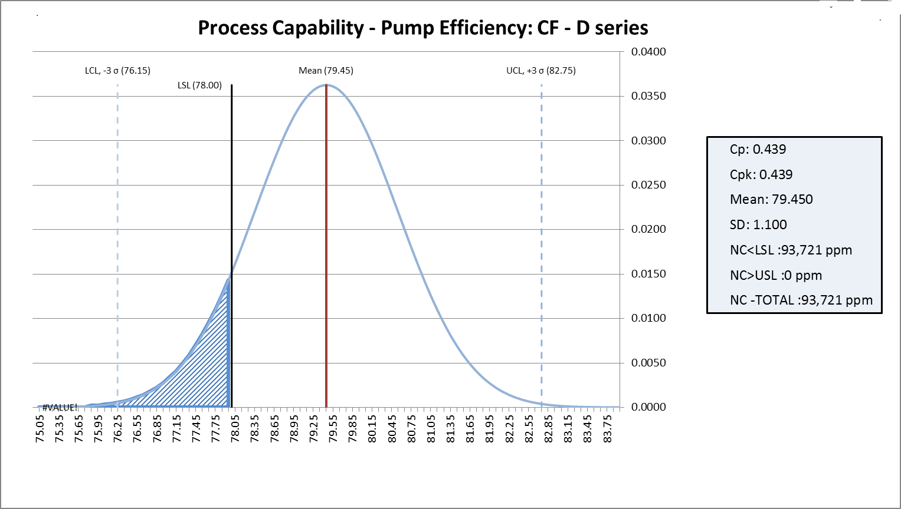

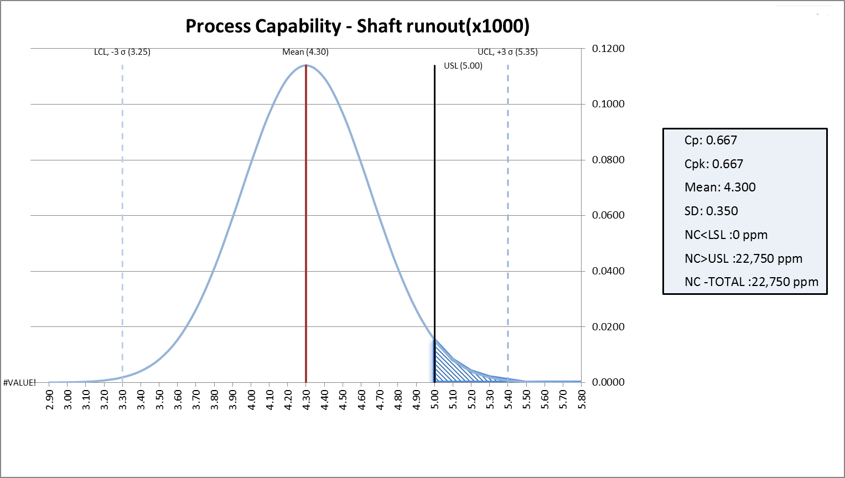

# Ex – 8 Control Charts

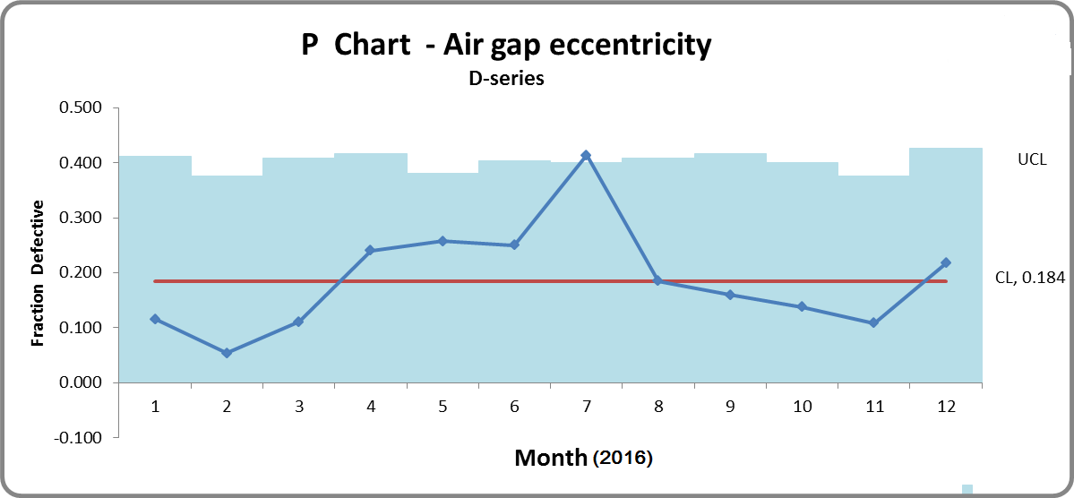

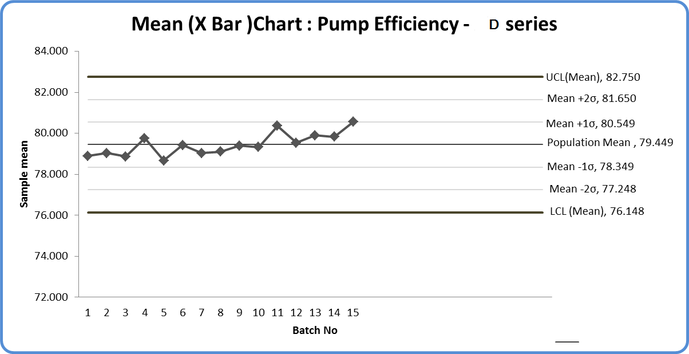

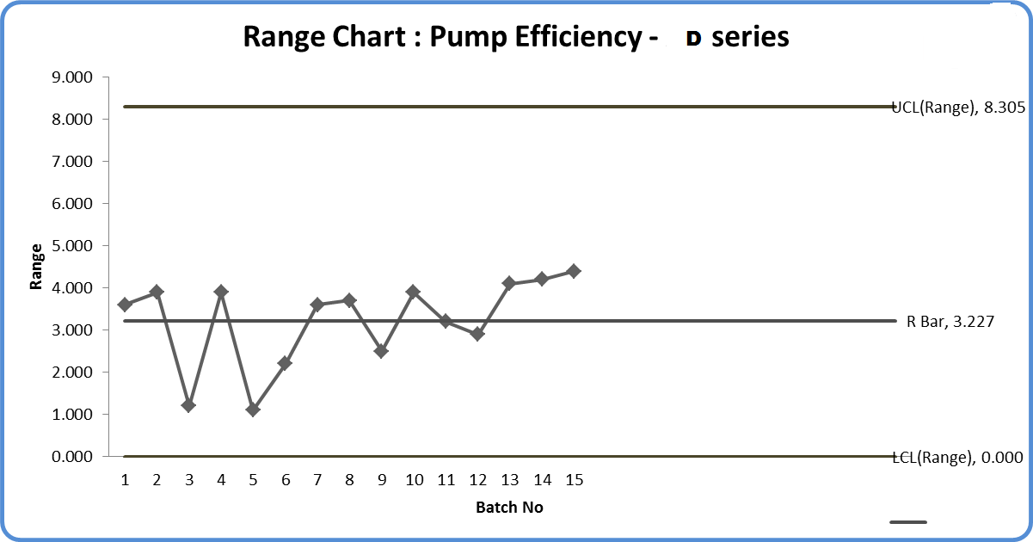

# Ex – 9 Fault Analysis Reports

**Motor (D-Series) : Fault Analysis**

|  |  |  |  |  |  |  |  |
| --- | --- | --- | --- | --- | --- | --- | --- |
|  | Jul - 16 | Aug-16 | Sep-16 | Oct-16 | Nov-16 | Dec-16 | Total |
| Rotor - static unbalance | 1 | 2 | 0 | 2 | 1 | 2 | 8 |
| Rotor - couple unbalance | 0 | 1 | 0 | 1 | 0 | 0 | 2 |
| Cracked Rotor bar | 0 | 1 | 1 | 0 | 0 | 1 | 3 |
| End rings joint | 3 | 5 | 5 | 9 | 4 | 4 | 30 |
| Air gap eccentricity | 12 | 5 | 8 | 4 | 7 | 6 | 42 |
| Bearing jammed | 2 | 0 | 3 | 0 | 2 | 0 | 7 |
| Rotor winding failure | 1 | 0 | 2 | 0 | 3 | 3 | 9 |
| Stator winding failure | 0 | 1 | 0 | 0 | 1 | 0 | 2 |
|  | 19 | 15 | 19 | 16 | 18 | 16 | 103 |

**Centrifugal Pump (XU Series) : Fault Analysis**

|  |  |  |  |  |  |  |  |
| --- | --- | --- | --- | --- | --- | --- | --- |
|  | Jul - 16 | Aug-16 | Sep-16 | Oct-16 | Nov-16 | Dec-16 | Total |
| Hydrostatic test | 3 | 2 | 4 | 2 | 5 | 2 | 18 |
| Vibration Noise | 1 | 0 | 1 | 1 | 0 | 0 | 3 |
| Alignment | 4 | 3 | 7 | 2 | 7 | 8 | 31 |
| Impeller unbalance | 12 | 9 | 13 | 12 | 9 | 8 | 63 |
| Performance Test – Duty point | 2 | 1 | 0 | 1 | 0 | 2 | 6 |
| Performance Test - Efficiency | 5 | 4 | 6 | 10 | 4 | 7 | 36 |
|  | 27 | 19 | 31 | 28 | 25 | 27 | 157 |

# Ex – 10 : Cost Of Poor Quality

|  |  |  |  |
| --- | --- | --- | --- |
| **COST OF POOR QUALITY (CENTRIFUGAL / MONOBLOCK PUMPS)** | | | |
|  |  |  |  |
| Year | 2013-14 | 2014-15 | 2015-16 |
| Production | 790 | 815 | 922 |
| Rejection Nos | 19 | 11 | 9 |
| Rejection Cost | 3198734 | 2092025 | 1903471 |
| Rework Nos | 75 | 72 | 85 |
| Rework Cost | 2234671 | 2344001 | 2901223 |
| Additional Qty inspection cost | 232050 | 218890 | 314575 |
| Additional consumable cost | 134050 | 160075 | 204565 |
| Total cost | 5799505 | 4814991 | 5323834 |
| Cost of poor Quality per pump | 7341 | 5908 | 5774 |

|  |  |  |  |
| --- | --- | --- | --- |
| **COST OF POOR QUALITY (VERTICAL / SUBMERSIBLE PUMPS)** | | | |
|  |  |  |  |
| Year | 2013-14 | 2014-15 | 2015-16 |
| Production | 168 | 252 | 281 |
| Rejection Nos | 2 | 2 | 1 |
| Rejection Cost | 2166667 | 2230159 | 1316726 |
| Rework Nos | 55 | 42 | 27 |
| Rework Cost | 1905500 | 1733245 | 1103329 |
| Additional Qty inspection cost | 560445 | 493320 | 350345 |
| Additional consumable cost | 310087 | 280332 | 169930 |
| Total cost | 4942699 | 4737056 | 2940330 |
| Cost of poor Quality per pump | 29421 | 18798 | 10464 |

# Ex – 11 : List of Kaizen Projects executed

|  |  |  |  |
| --- | --- | --- | --- |
|  | Project Title | Benefits from project | Period |
| 1 | Mistake proofing of Production drawings prepared using AUTO- CAD (importing 2D images to 3D Modeling works) | * Errors of 2D Drawings reduced from 28% to 6 % * Rework /Rejection cost reduced * Quality of product is improved | Apr – May 2015 |
| 2 | Shut off the painting nozzle automatically if compressor pressure drops | * Painting rework reduced from 18 % to 0 * Cost savings in paint consumption * Painting waste (effluent) reduced | Aug-Sep 2015 |
| 3 | Reduction in cutting tool (Rough milling inserts) change time | * Insert change time reduced from 10 minutes to 1 minute * Increase in productivity * Time loss of 375 minutes per month brought down to 25 minutes | Aug-Sep 2015 |
| 4 | Conversion of manually operated electrical hoist to inclined (gravity) track | * Working steps reduced from 12 to 1 * Cycle time reduction from 40 seconds to 5 seconds * Energy consumption of Rs 45000/= per annum reduced to zero * Operation Safety score improved | Oct 2015 |
| 5 | Change overhead grinding of Pump housing flange to floor grinding by reversal of job | * Improved ergonomics easier access– reduce worker fatugue * Improvement in cycle time from 25 minutes/job to 17 minutes * Enregy savings -approx Rs 24000/= per annum * Increased safety – elimination of burrs falling in eyes | Oct-Nov 2015 |
| 6 | Reduction of PVC Winding wire defects by improving cable extrusion process at Vendor end by changing master batch | * Reduction of Motor burnout (external complaints) from 5 (2015) to NIL in 2016 | April-May 2016 |
| 7 | To reduce the testing time of Vertical Turbine Pump by changing and standardizing the clamping fixture | * Reduction in average testing time from 55 minutes to 25 minutes * Reduced capital expenditure of designing special fixture for every model (approx 45000/= per ficture) | April – May 2016 |
| 8 | To eliminate pipe damage in CNC Bending machine by providing additional attachment | * Pipe damage brought doen from 173 in June 2016 to 0 in August 2016 * Operator involvement eliminated – reduced fatigue * Operator safety improved | June – July 2016 |

# Waste Reduction

# Ex – 12 : 3 M Project executed

|  |  |  |  |
| --- | --- | --- | --- |
|  | Project Title | Benefits from project | Period |
| 1 | To reduce the MUDA of Inventory | Productivity increased from 6 Kits to 11 Kits per person by reduction in searching time, rejected parts mixing & inventory levels  24 % Space saved  Stocking reduction from 250 motor kits to 110 Kits & pump components from 450 sets to 250 sets and valves parts reduction from 540 sets to 350 Sets that resulted in inventory cost reduction from Rs 1. 6 cr to Rs 73 Lacs (financial saving of Rs 11.56 Lacs per annum) | Apr – May 2015 |

# Customer quality

# Ex – 13 : Customer ratings (Scale of 10)

(Based on response received from 15 customers)

|  |  |  |  |
| --- | --- | --- | --- |
|  | **2014** | **2015** | **2016** |
| Satisfaction with the quality and relaibility of our products | 5.25 | 6.5 | 8.25 |
| Satisfaction with our delivery commitments | 6.25 | 5.5 | 7.75 |
| Satisfaction with our commissioning and installation services | 7.75 | 8.25 | 8.50 |
| Satisfaction with our response to breakdowns | 5.75 | 6.25 | 7.0 |
| Satisfaction with the competence of our technical staff | 3.25 | 5.0 | 5.5 |

# Ex – 14 : Customer Complaints

|  |  |  |  |
| --- | --- | --- | --- |
|  | **2014** | **2015** | **2016** |
| Centrifugal pumps / Monoblocks | 18 | 52 | 36 |
| Subsmersible Vertical Turbine pumps | 2 | 3 | 4 |
| Sluice Valves / Footvalves | 5 | 21 | 11 |
| Spares | 4 | 9 | 15 |

# Equipment Performance

# Ex – 15 : OEE (%)

|  |  |  |  |
| --- | --- | --- | --- |
| Equipment | 2014 | 2015 | 2016 |
| Vertical Turret Lathe | 75 | 76 | 78 |
| CNC Lathe | 67 | 72 | 75 |

# Ex – 16 : Breakdown (% of available hours)

|  |  |  |  |
| --- | --- | --- | --- |
| Equipment | 2014 | 2015 | 2016 |
| Vertical Turret Lathe | 0.060 | 0.545 | 0.023 |
| CNC Lathe | 1.3 | 0.81 | 0.98 |
| Stator assembly line | 4.5 | 5.5 | 6.6 |

# Ex – 17 : Energy Consumption

|  |  |  |  |  |  |  |
| --- | --- | --- | --- | --- | --- | --- |
| Equipment | 2014 | | 2015 | | 2016 | |
|  | Target | Achieved | Target | Achieved | Target | Achieved |
| Energy consumption (kwh) per equipment sold | 1000 | 1100 | 850 | 980 | 750 | 765 |

# Ex – 18 : Environmental Performance

|  |  |  |  |
| --- | --- | --- | --- |
| **Activity** | **Aspect** | **Impact** | **Control/ improvements undertaken** |
| Curing oven | Use of electricity | Depletion of natural resources | Reduced per unit consumption of electrical energy by increasing the furnace capacity by 30 % in 2015 |
| Epoxy resin fumes emission to air | Non GHG Air pollution – mild health impact to workers | Emission way below threshold level and complies with statutory norms.  Ventilating fan in workshop evacuates fumes |
| Resin spillage/  collected dust | Increased waste to landfill | Waste segregation at source. Complies with statutory norms. |
| Casting (at vendor end) | Emission to air | Air pollution |  |
| Binder residue | Increased waste to landfill | Waste segregation at source |
| Accidental spillage of molten metal | Contamination of soil/ Depletion of natural resources | Developed control process / emergency plan to deal with situation |
| Generation of noise | Discomfort | Use of ear plugs commenced |
| Machining | Generation of cutting & grinding waste | Land pollution | Waste segregation at source. Complies with statutory norms. |
| Machine oil spillage | Contamination of soil | Issue of work instructions |
| Discharge of used machine oil | Contamination of water | Discharge way below threshold level - complies with statutory norms..  Reduced the use of machine oil  Partial switch to water based machine oil |
| Degreasing & cleaning process | Emission to air (vaporised solvent) | Air pollution (low impact) | Discharge way below threshold level - complies with statutory norms. |
| Liquid waste discharge | Water pollution | Discharge way below threshold level - complies with statutory norms. |
| Painting | Air emission of solvent | Air pollution | Discharge way below threshold level - complies with statutory norms.  Switched to use of lead free / water based paints |
| Discharge of waste solution | Water pollution | -do- |

# Ex – 19 : Employee productivity

|  |  |  |  |
| --- | --- | --- | --- |
|  | 2014 | 2015 | 2016 |
| Sales/employee (direct) in lakhs | 31.13 | 42.35 | 59.83 |
| Sales/employee  (direct+non direct) in lakhs | 23.87 | 32.47 | 45.87 |
| Pump industry average Sales/employee in lakhs | 28.5 | 30.7 | 32.8 |

# Ex – 20 : Internal Management Review : Summary Report

|  |  |
| --- | --- |
| **Strengths:** | **Weaknesses** |
| * Long standing market presence * High customer orientation by Top management * Customer Relationship Management (CRM) * Recognition by key customers * Customer loyalty * Competitive Price to Quality ratio * Core capability (design /engineering/manufacturing /marketing/tool room), * Positive organization culture * Low employees attrition * Delivered product quality – few complaints * Good Product mix to serve varying customer needs, * Technology edge | * Product quality – process rejections are high in manual, semi-automatic processes * Lack of organized HR practices * Skill mapping not carried out for all roles, especially in critical processes * Process instability in some areas * Lack of systems coordination among divisions * High receivables * Cost management * Many types of wastages are not yet controlled * Technical functions not aligned with customers * Data capturing and analysis is not being utlized for process improvements * Project management capability is lacking * Current ppm levels not commensurate with export market targets |